
QUESTION PAPER | : | LAB ASSIGNMENT-9 | SHEET : 1 OF 1
COURSE TITLE | : | JAVA | BATCH NO :
MODULE | : | Class,Methods,Static Methods | MARKS :
TIME | : |  | DATE :

Q.1  Q.2  Q.3  Q.4  Q.5 | 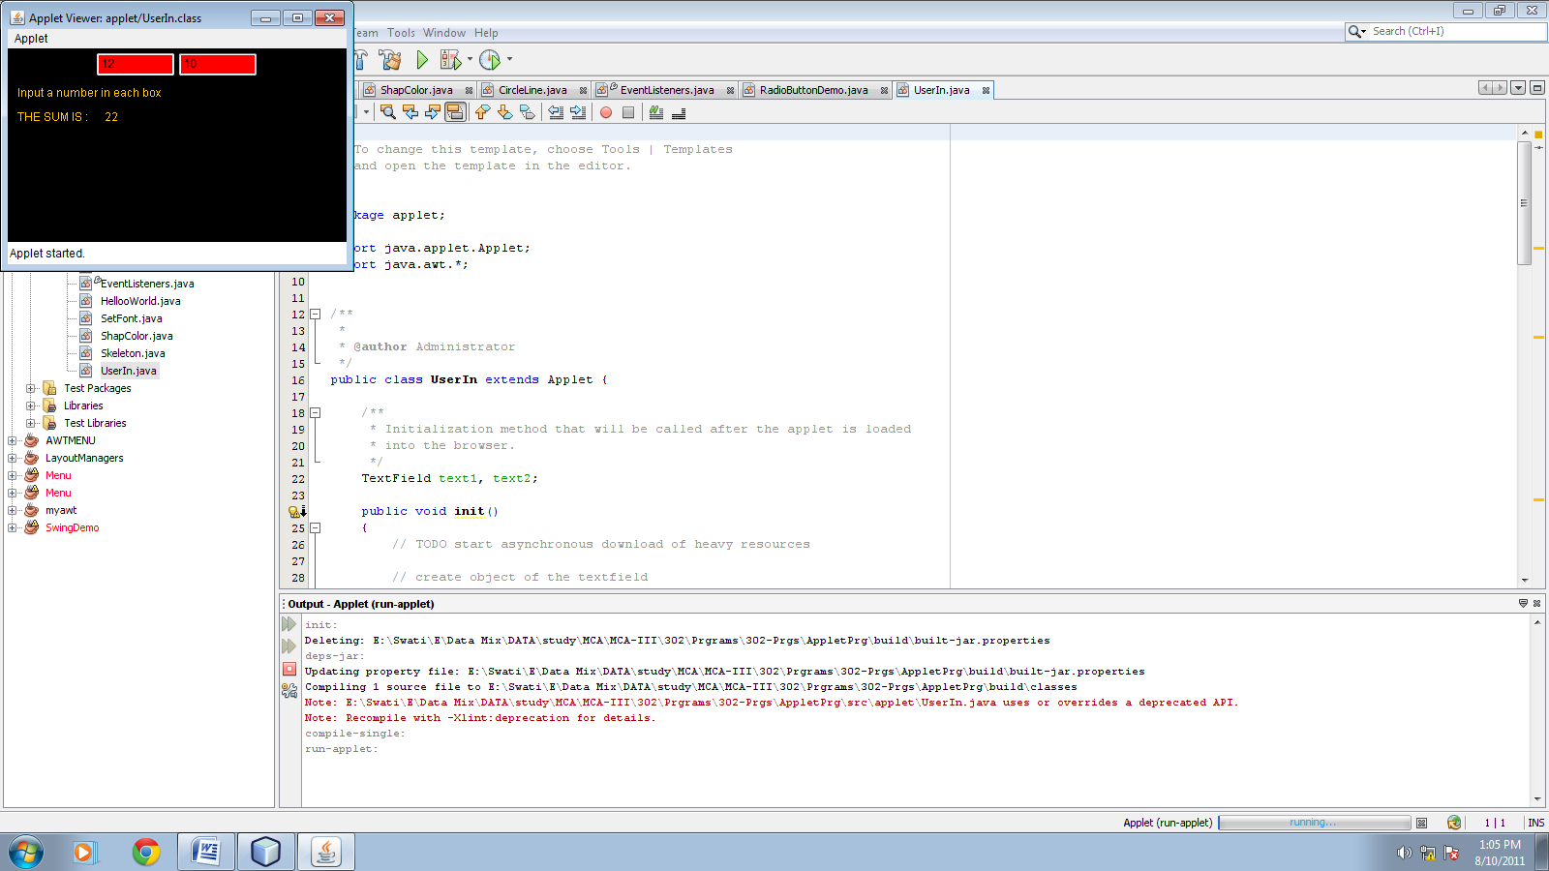  Uisng AWT package, write a Java program to create an applet window. Add two TextField named as tf1 and tf2 onto the applet window as per given demo above. Enter value into each textfield and By pressing enter key, it should display the sum result as a string onto the applet window . Use flowlauout manager to positioning the buttons  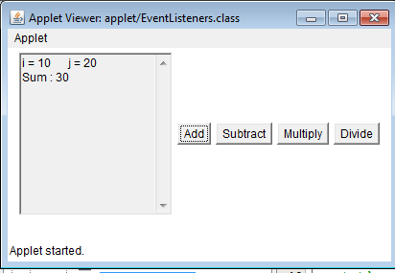  Write a Java program to create an applet window. Add four Button control named as addbtn, subbtn, mulbtn and divbtn and labeled is same as per given in above demo.Add TextArea named as ta1 onto the applet window as per given demo above. Now take two variable having the static value i=10 and j=20 for doing arithmetic operation. By clicking on the each button, result should be display onto the TextArea control. Use flowlauout manager to positioning the buttons.  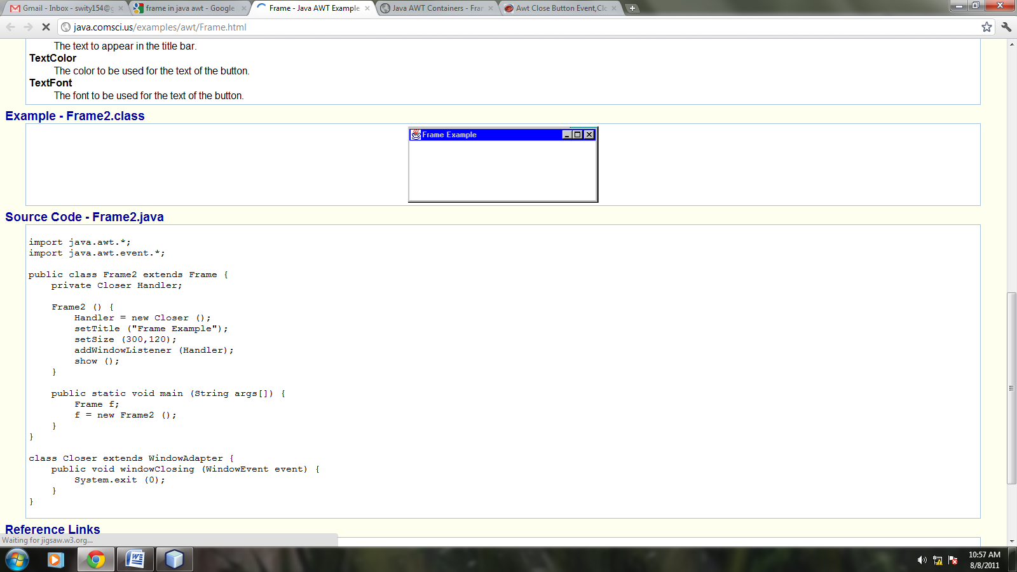  Create a frame window that should have a title “Frame Example”. Also change the background color of the frame. Set the size of the frame as “Width = 400” and “Height = 400”. Note that application should be close from close button given on the frame window.  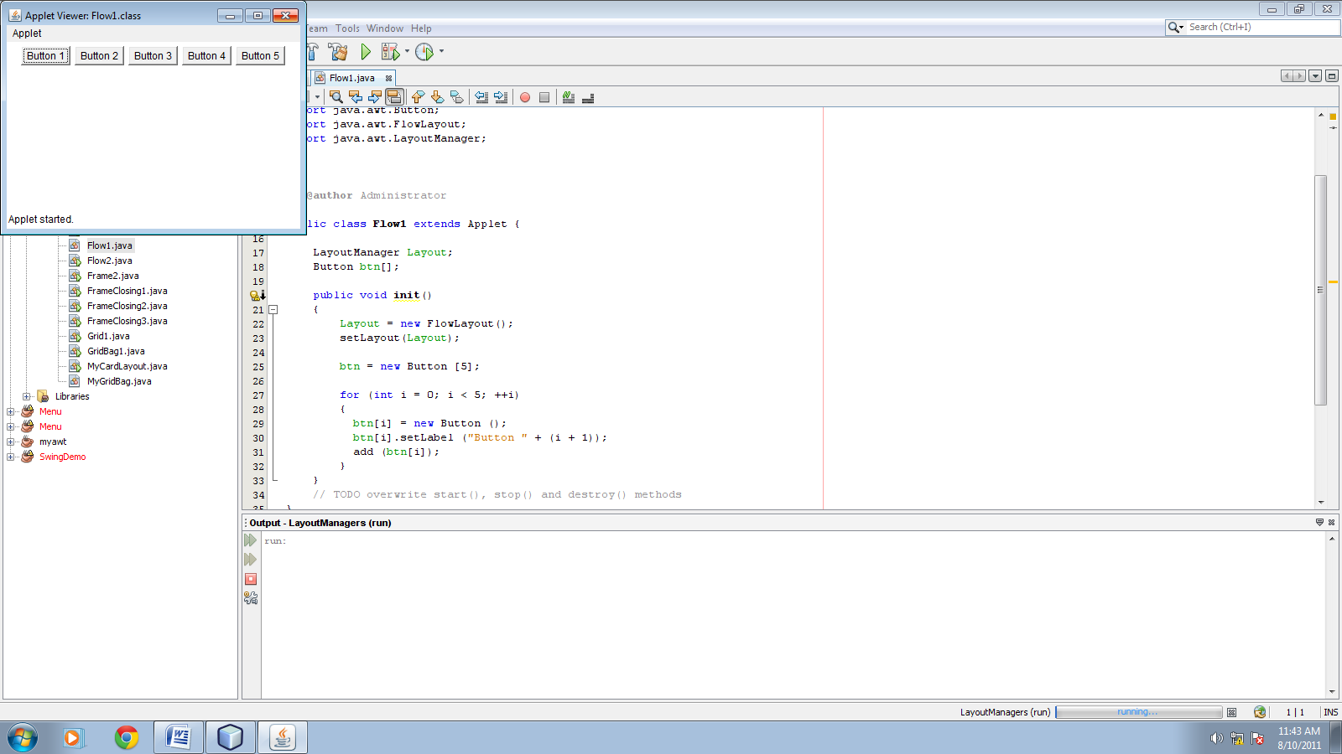  Using AWT package, write a Java program to create an applet window. Add number of buttons onto the applet window as per given demo above. Use flowlauout manager to positioning the buttons. Give horizontal gap as 20 and vertical gap as 30 between the controls.  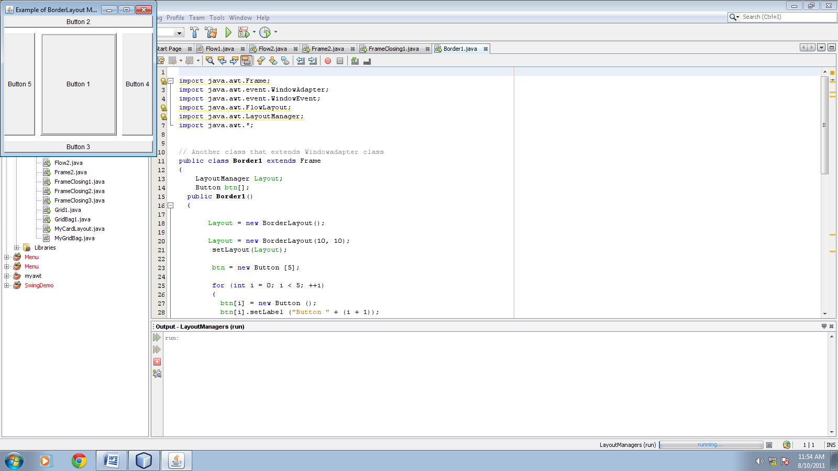  Using AWT package, write a Java program to create a farme window. Give the title of the frame is “Example of BorderLayout Manager” and Set the size of the frame as “Width = 300” and “Height = 400”. Add number of buttons onto the frame window as per given demo above. Use BorderLayout manager to positioning the buttons. Give horizontal gap as 20 and vertical gap as 30 between the control. Note that application should be close from close button given on the frame window.gap as 20 and vertical gap as 30 between the controls.

